**PES Institute of Technology, Bangalore**

(Autonomous Institute under VTU, Belgaum)

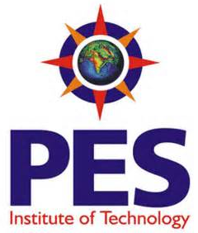

C++ PROJECT REPORT ON

***“RAILWAY RESERVATION SYSTEM”***

**Department of Information Science and Engineering**

**(2013-2014)**

**Team:**

1. SPOORTHY S GOWDA [ISDIP009]
2. VISHAL [1PI12IS126]

**Guide:** Mr. VINAY VASISTA

**Signature:**

**HOD:** Mrs. SHYLAJA S S

**Signature:**

Date of Submission: **23-11-2013**